|  |  |  |
| --- | --- | --- |
| Tech Saksham  **Final Project Report** |  |  |

**“HEART DISEASE PREDICATION”**

**AIMAN COLLEGE OF ARTS & SCIENCE FOR WOMEN, K.SATHANUR, TRICHY-620 021**

|  |  |
| --- | --- |
| **ROLL NO** | **NAME** |
| **CB20S 199518** | **K. Afifa** |
| **CB2OS 259893** | **M. Kowfar Thakshin Fathima** |
| **CB20S 199540** | **S. Thaslim Banu** |
| **CB20S 199541** | **V. Usha** |

|  |  |
| --- | --- |
|  |  |
|  | **Trainer Name: DEEP DIVE** |
|  | **Master Trainer:Mayank shrivastava** |

**INDEX**

|  |  |  |
| --- | --- | --- |
| **Sr. No.** | **Table of Contents** | **Page No** |
| 1 | Chapter 1: Introduction |  |
| 2 | Chapter 2: Services and Tools Required |  |
| 3 | Chapter 4: Architecture Blocks Detail Working |  |
| 4 | Conclusion |  |
| 5 | References |  |
| 6 | Code |  |

**APSTRACT**

Disease Prediction using Machine Learning is system which predicts the disease based on the information or the symptoms he/she enter into the system and provides the accurate results based on that information. If the patient is not much serious and the user just wants know the type of disease, he/she has been through. It is a system which provides the user the tips and tricks to maintain the health system of the user and it provides a way to find out the diseases using this prediction. Now a day’s health industry plays major role in curing the diseases of the patients so this is also some kind of help for the health industry to tell the user and also it is useful for the user in case she/he doesn’t want to go the hospital or any other clinics, so just by the entering the symptoms and all other useful information the user get to know the disease he/she is suffering from and the health industry can also get benefit from this system by just asking the symptoms from the user and entering in the system and in just few seconds they can tell the exact and up to some exte4nd the accurate disease. This Disease Prediction Using Machine Learning is completely done with the help of Machine Learning and Python Programming language for it and also using the dataset that we will predict the disease. “Disease Prediction” app based on predictive modeling predicts the disease of the user on the basis of the symptoms that provides as an input to the app. The app analyzes the symptoms provided by the user as input and gives the probability of the disease as an output. Disease Prediction is done by implementing the Decision Tree Algorithm.

**CHAPTER 1**

**INTRODUCTION**

* 1. **Overview**

**The project Disease Prediction using Machine Learning is developed to overcome general disease in earlier stages as we all know in competitive environment of economic development the mankind has involved so much that he/she is not concerned about health according to research there are 40% peoples how ignores about general disease which leads to harmful disease later. The Project "Disease Prediction using Machine Learning" is implemented using python completely. Even the interface of this project is done using Flutter frame work. Here first the user needs to register into the system in order to use the prediction, user needs to register with username, email-id, phone, age and password.**

**At present, when one suffers from**

**particular disease, then the person has to visit to doctor which is time consuming and costly too. Also if the user is out of reach of doctor and hospitals it may be difficult for the user as the**

**\disease can not be identified. So, if the above process can be completed using a automated program which can save time as well as money, it could be easier to the patient which can make the process easier. There are other Heart related Disease Prediction App using data mining techniques that analyzes the risk level of the patient. Disease Predictor is a Mobile Application that predicts the disease of the user with respect to the symptoms given by the user. Disease Prediction App has data sets collected from different health related sites. With the help of Disease Predictor the user will be able to know the probability of the disease with the given symptoms.**

**1.2 Problem Statement**

There are many tools related to disease prediction. But particularly heart related diseases have been analyzed and risk level is generated. But generally there are no such tools that are used for prediction of general diseases. So Disease Predictor helps for the prediction of the general diseases**.**

**1.3 Features**

**Patient Login:**

* User Login to the system using his Email and Password**.**

**Patient Registration:**

* If User is a new user he will enter his personal details and he will user Id and password through which he can login to the system.

**Disease Prediction:**

* User will specify the symptoms caused due to his illness. System will ask certain question regarding his illness and system predict the disease based on the symptoms specified by the patient and system will also suggest doctors basedon the disease.

**Feedback:**

* User will give feedback this will be reported to the admin.

**Diseases Dictionary:**

* User can study and read all information (Like Introduction Causes, Symptoms & Treatment) about different diseases.

**1.4 Advantages & Disadvantages:**

**1.4.1 Advantages:**

→ User can diagnose disease from their symptoms

No waste of time quick service in emergency

→ Quick first aid from home

→ Easy to carry medical knowledge without even knowing it

**1.4.2 Disadvantages:**

* The system is not fully automated; it needs doctors for full diagnosis.

**1.5 Scope**

This project aims to provide a mobile app platform to predict the occurrences of disease on the basis of various symptoms. The user can select various symptoms and can find the diseases with their probabilistic figures.

**1.6 Future Work:**

Every one of us would like to have a good medical care system and physicians are expected to be medical experts and take good decisions all the time. But it's highly unlikely to memorize all the knowledge, patient history, records needed for every situation. Although they have all the massive amount of data and information, it's difficult to compare and analyse the symptoms of all the diseases and predict the outcome. So, integrating information into patient's personalized profile and performing an in-depth research is beyond the scope a physician. So the solution is ever heard of a personalized healthcare plan-exclusively crafted for an individual. Predictive analytics is the process to make predictions about the future by analyzing historical data. For health care, it would be convenient to make best decisions in case of every individual. Predictive modeling uses artificial intelligence to create a prediction from past records, trends, individuals, diseases and the model is deployed so that a new individual can get a prediction instantly. Health and Medicare units can use these predictive models to accurately assess when a patient can safely be released.

**CHAPTER 2**

**SERVICES AND TOOLS REQUIRED**

**2.1 Tools:**

**Android Studio 2.1.1**

**⚫Visual Studio Code (IDE)**

**⚫ Flutter 2.0.3**

**⚫ PyCharm 2020.35**

**2.1.2 Language:**

**• Dart**

* **Python**
* **3.1.4 Non-functional requirements**

**a. Display the list of symptoms where user can select the symptoms.**

**b. Decision Tree Algorithm is used to classify the data sets.**

**2.2 Feasibility Analysis:**

**2.2.1 Technical feasibility**

* **The project is technically feasible as it can be built using the existing available technologies. It is a web based applications that uses Grails Framework. The technology required by Disease Predictor is 3.2.2 Economic feasibility available and hence it is technically feasible.**
* **The project is economically feasible as the cost of the project is involved only in the hosting of the project. As the data samples increases, which consume more time and processing power. In that case better processor might be needed.**

**2.2.2 Operational feasibility**

* **The project is operationally feasible as the user having basic knowledge about computer and Internet.**
* **Disease Predictor is based on client-server architecture where client is users and server is the machine where datasets are stored.**

**CHAPTER 3**

**PROJECT ARCHITECTURE** Blocks Detail Working

**PROJECT ARCHITECTURE**

**3.1 Methodology**

**Disease Prediction has been already implemented using different techniques like Neural Network, decision tree and Naive Byes algorithm. Particularly heart related disease is mostly analyzed. From the analysis it was found that Naïve Bayes is more accurate than other techniques. So, Disease Predictor also uses Naive Bayes for the prediction of different diseases.**

**3.2 Data collection Data collection has been done from the internet to identify the disease here the real symptoms of the disease are collected Le. no dummy values are entered. The symptoms of the disease are collected from different health related websites.**

**3.3 Algorithm implemented**

**The algorithm implemented in this project is Decision Tree Algorithm**

**3.3.1 Decision Tree Algorithm: It is a sort of supervised learning algorithmic program that's largely used for classification issues. Surprisingly, it works for each categorical and continuous dependent variable. In this algorithmic program, we tend to split the population into 2 or a lot of homogenized sets. This is done supported most vital attributes/ freelance variables to form as distinct teams as attainable. A tree has several analogies in real world, and seems that it's influenced a large space of machine learning, covering each classification and regression. In call analysis, a choice tree is wont to visually and expressly represent selections and higher cognitive process. As the name goes, it uses a tree-like model of decisions. Though a commonly used tool in data mining for deriving a strategy to reach a particular goal, it's also widely used in machine learning. Once we completed modelling the Decision Tree classifier, we will use the trained model to predict whether the balance scale tip to the right or tip to the left or be balanced**

**CLASS DIAGRAM**

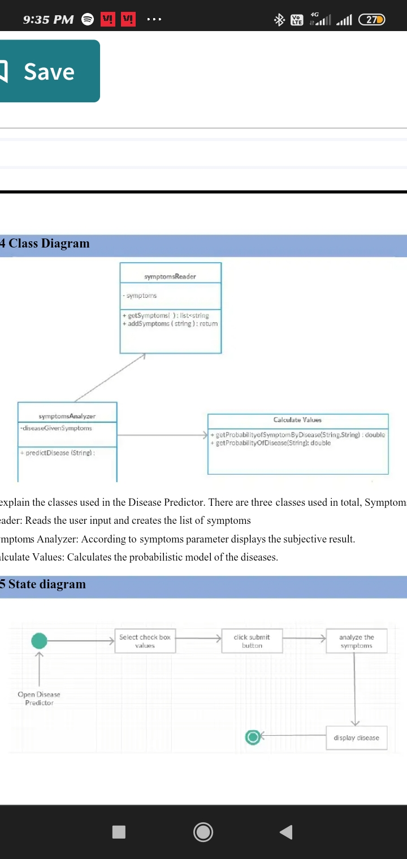

**SEQUENCE DIAGRAM**

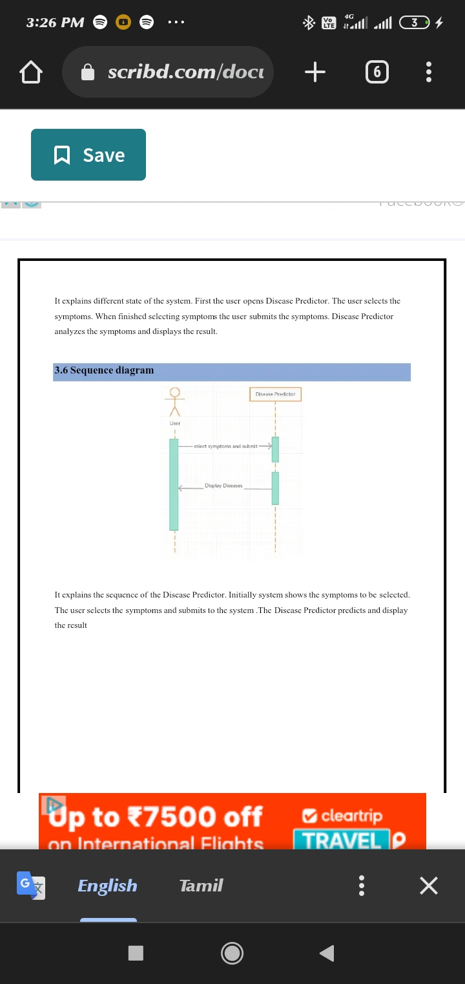

**CONCLUSION**

This system can be used by all patients or their family members who need help in emergency. Any normal person with little knowledge can handle this app easily can taste the fruit out of it. It contains vast knowledge about the diseases which can be carried all time by you anywhere and it will be available anytime to give its services.

**REFERENCES**

[1]Soni J, Ansari U, Sharma D and Soni S 2011 Predictive data mining for medical diagnosis: an overview of heart disease prediction International Journal of Computer Applications 17 43-8

Google Scholar

[2]Dangare C S and Apte S S 2012 Improved study of heart disease prediction system using data mining classification techniques International Journal of Computer Applications 47 44-8

Google Scholar

[3]Ordonez C 2006 Association rule discovery with the train and test approach for heart disease prediction IEEE Transactions on Information Technology in Biomedicine 10 334-43

Google Scholar

[4]Shinde R, Arjun S, Patil P and Waghmare J 2015 An intelligent heart disease prediction system using k-means clustering and Naïve Bayes algorithm International Journal of Computer Science and Information Technologies 6 637-9

Google Scholar

[5]Bashir S, Qamar U and Javed M Y An ensemble-based decision support framework for intelligent heart disease diagnosis International Conference on Information Society (i-Society 2014) (IEEE) 259-64

Google Scholar

[6]Jee S H, Jang Y, Oh D J, Oh B H, Lee S H, Park S W and Yun Y D 2014 A coronary heart disease prediction model: the Korean Heart Study BMJ open 4 e005025

Google Scholar

[7]Ganna A, Magnusson P K, Pedersen N L, De Faire U, Reilly M, Ärnlöv J and Ingelsson E 2013 Multilocus genetic risk scores for coronary heart disease prediction Arteriosclerosis, thrombosis, and vascular biology 33 2267-72

Google Scholar

[8]Jabbar M A, Deekshatulu B L and Chandra P Heart disease prediction using lazy associative classification 2013 International Mutli-Conference on Automation, Computing, Communication, Control and Compressed Sensing (iMac4s) (IEEE) 40-6

Google Scholar…

**APPENDIX**

**DATASET & CODE**

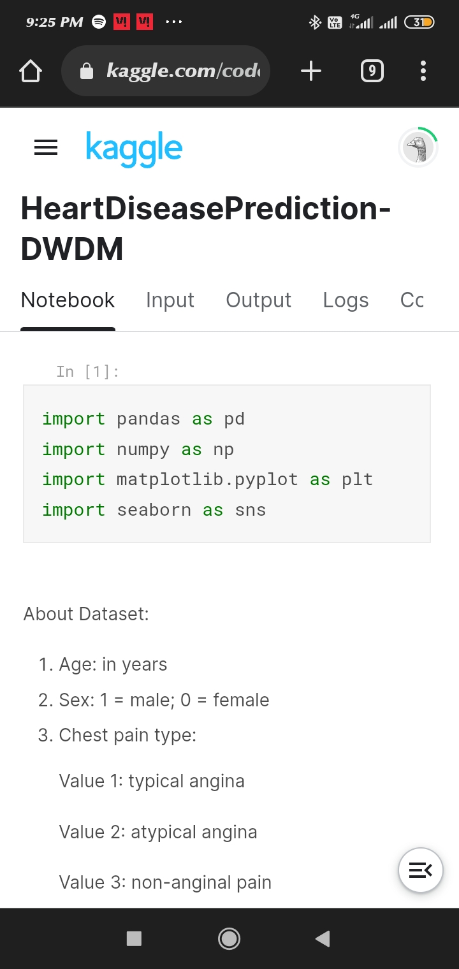

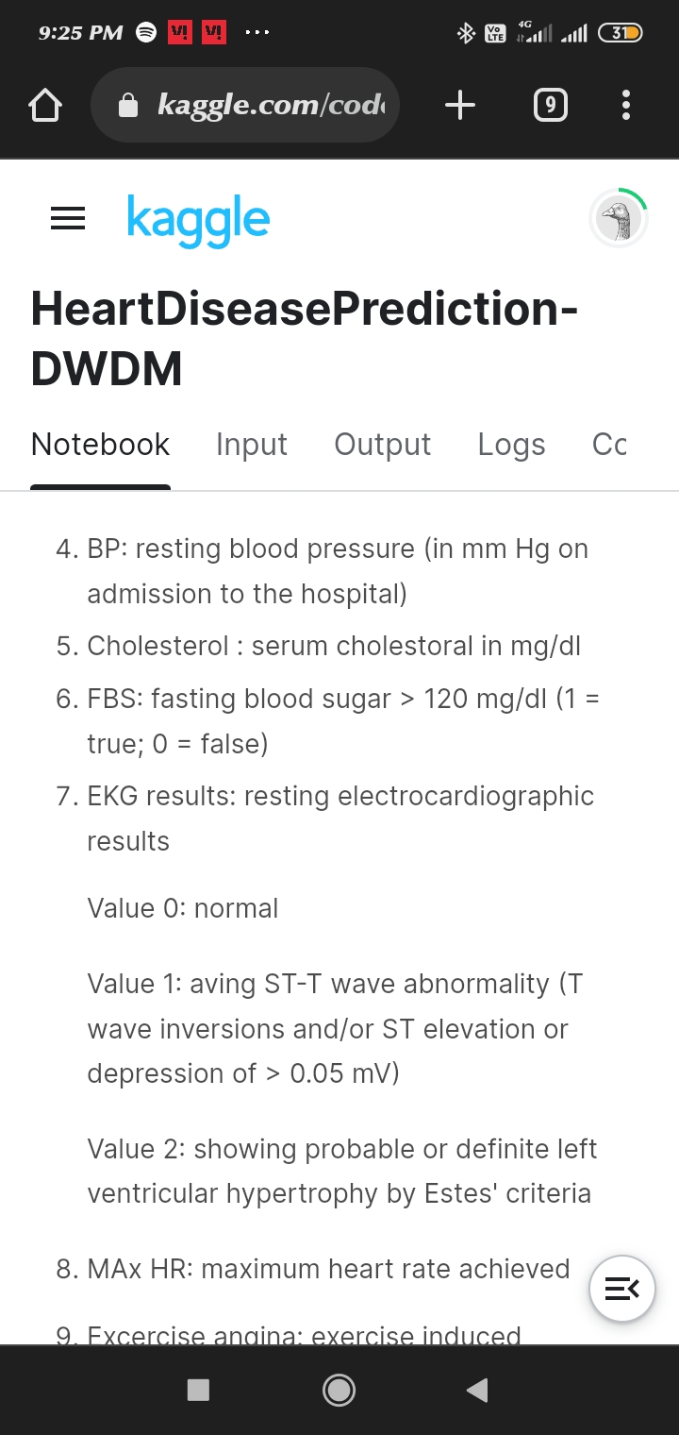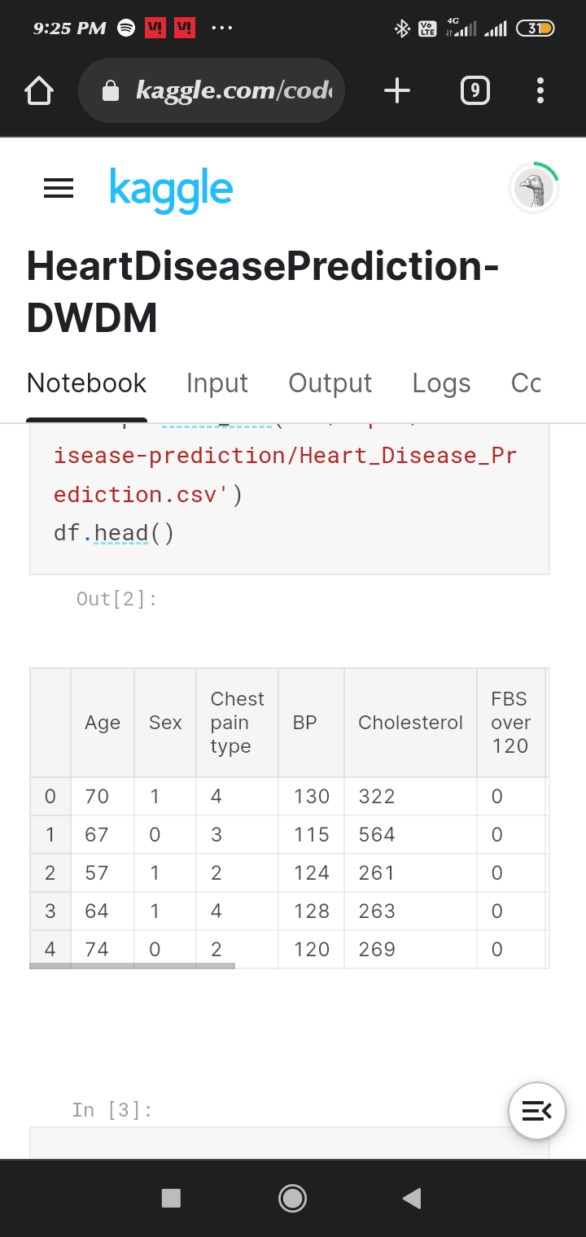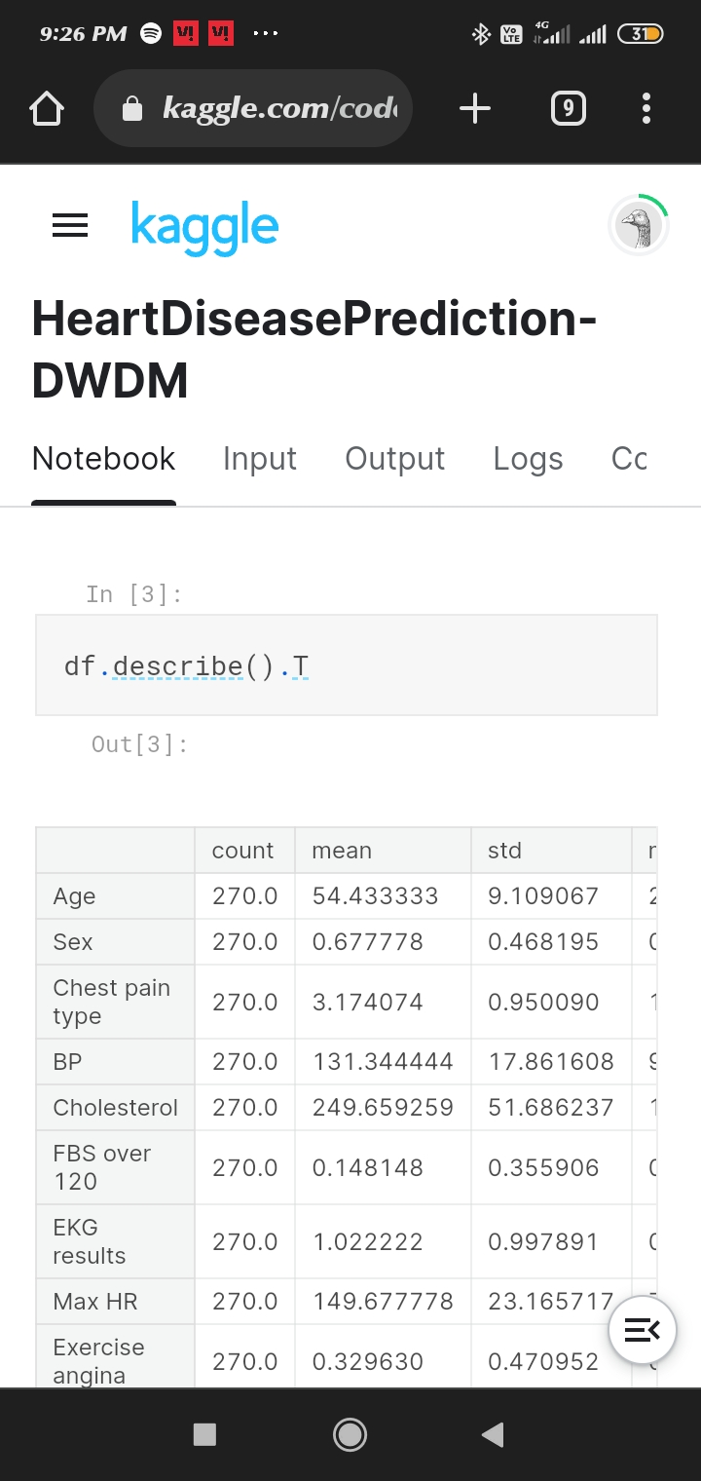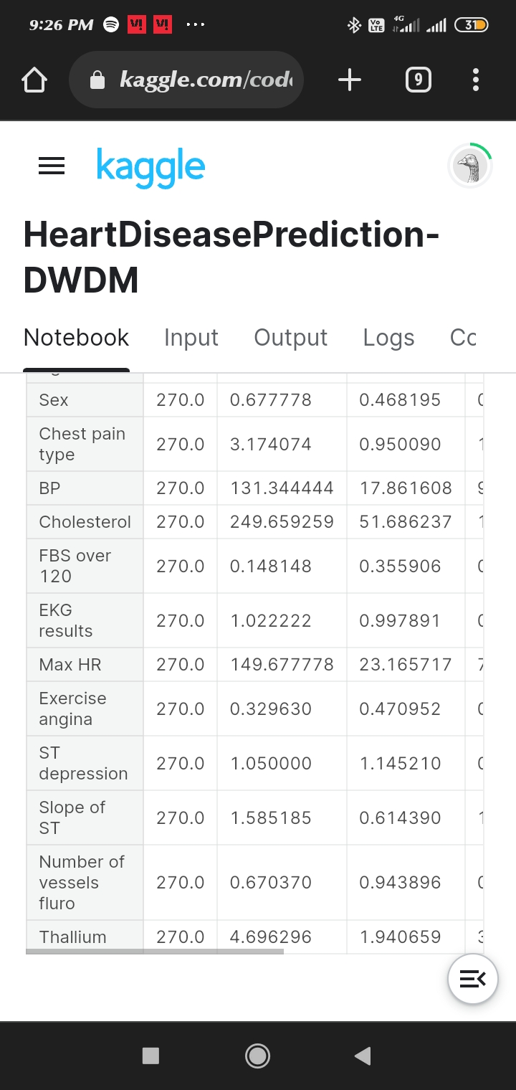

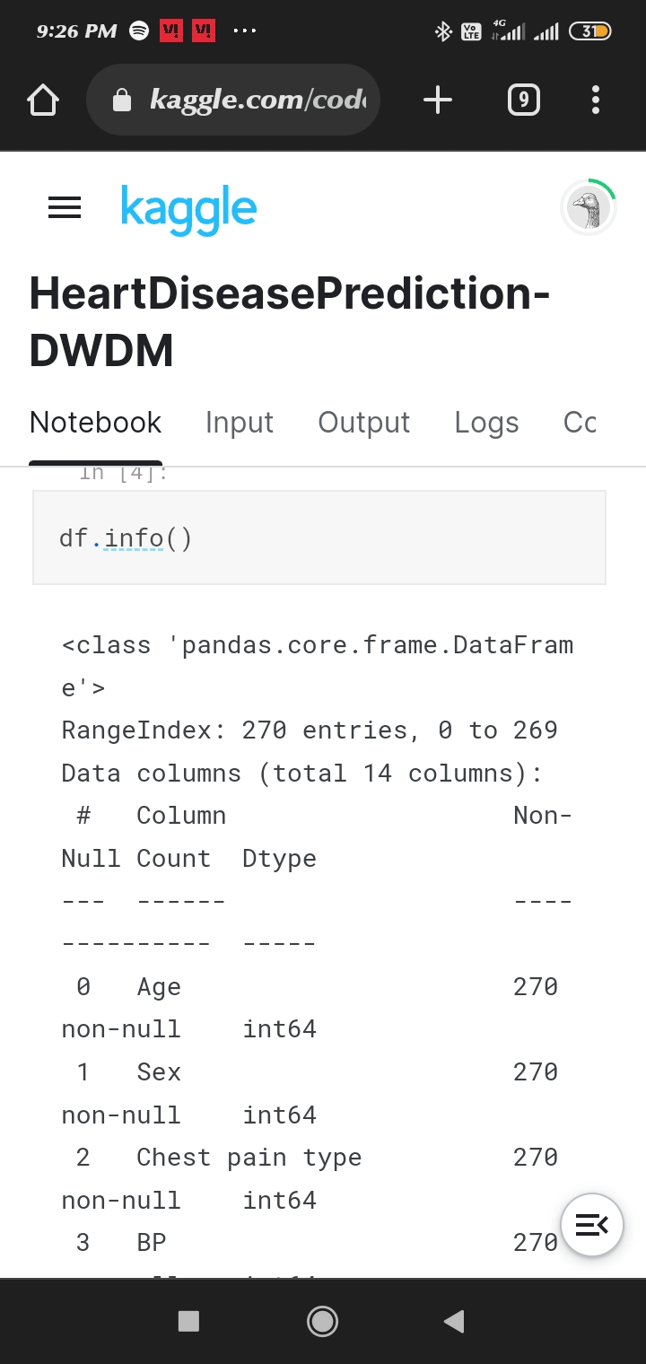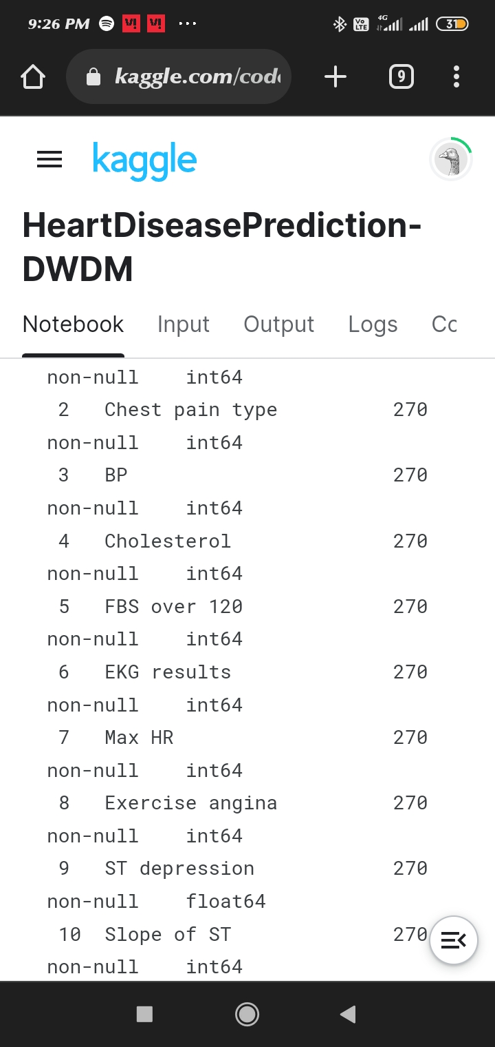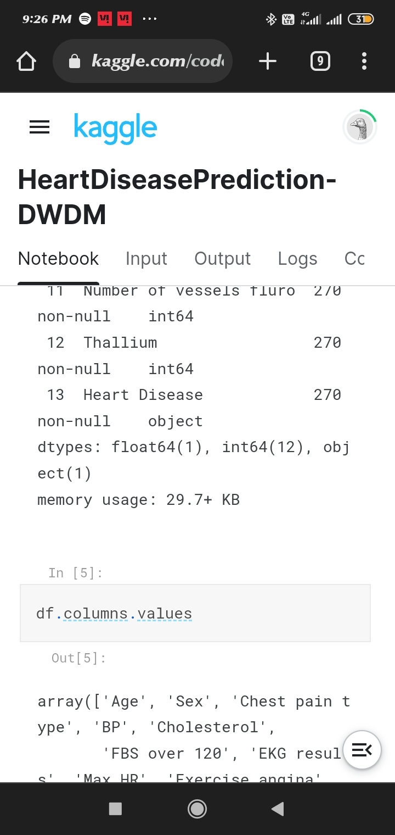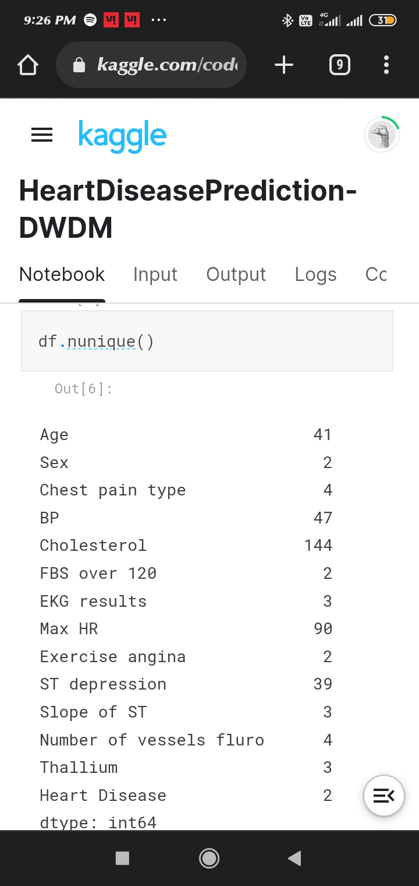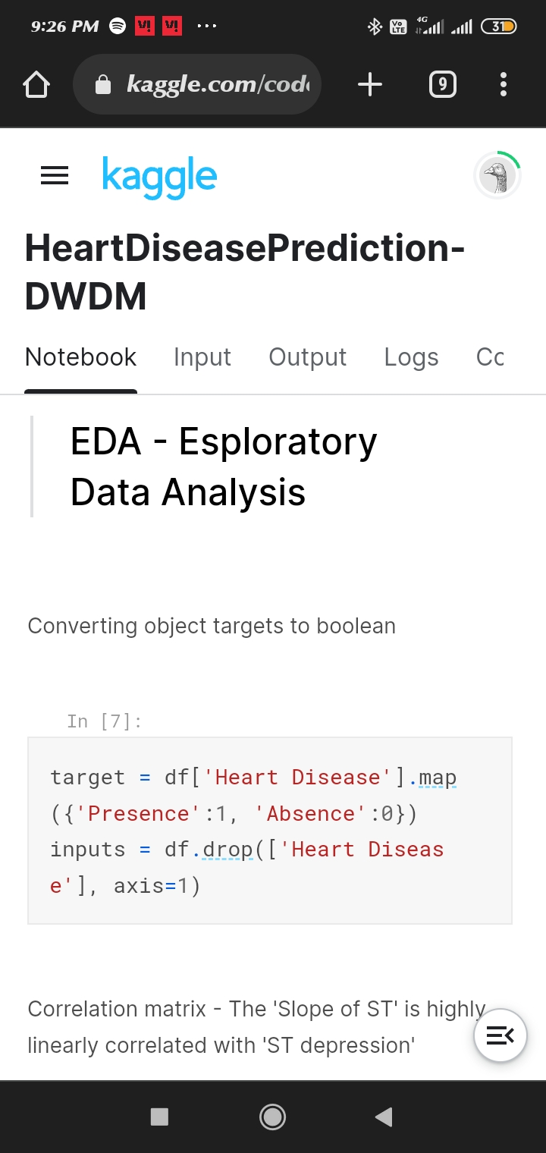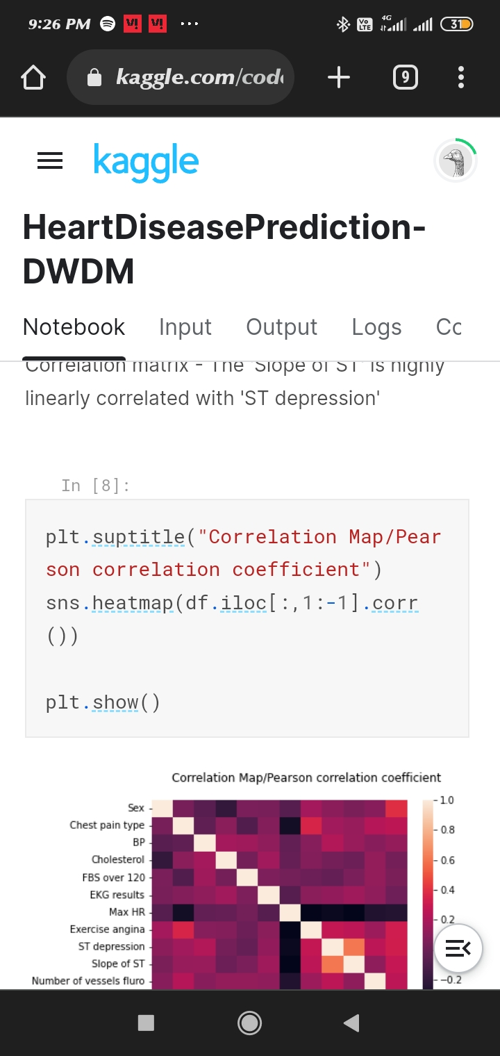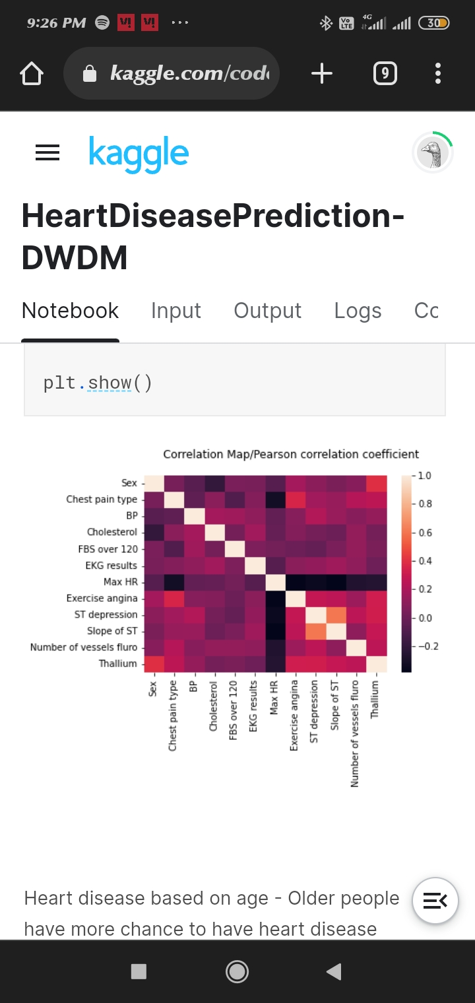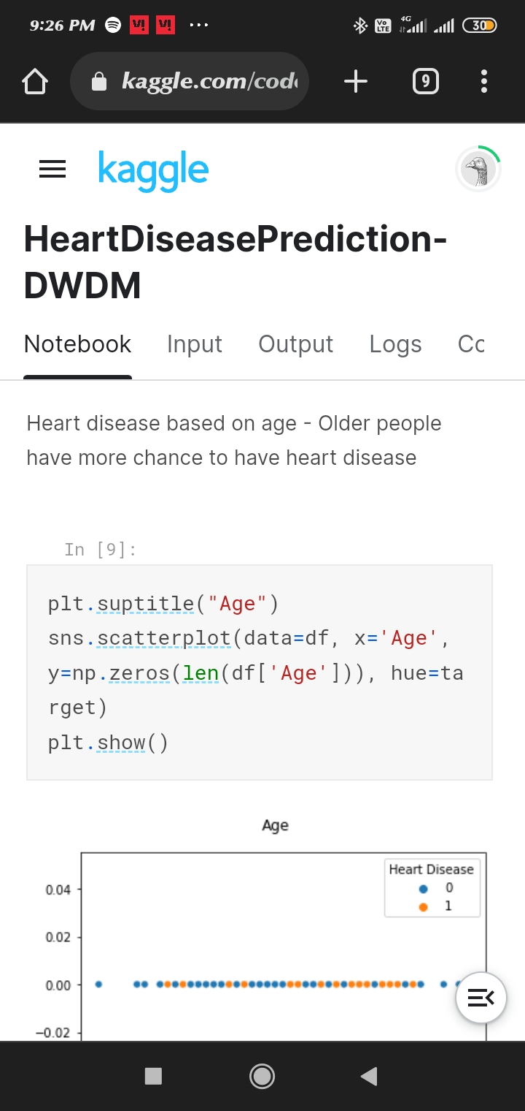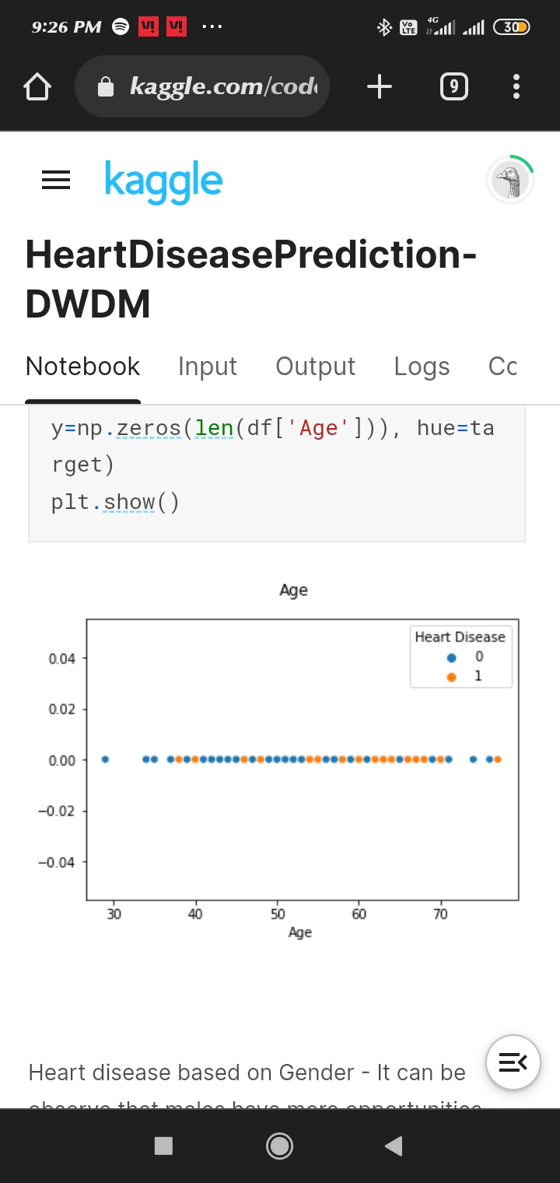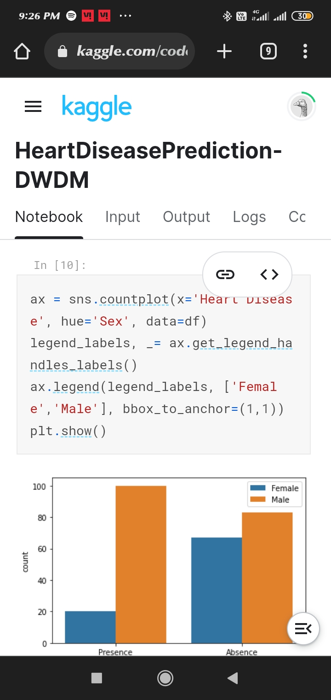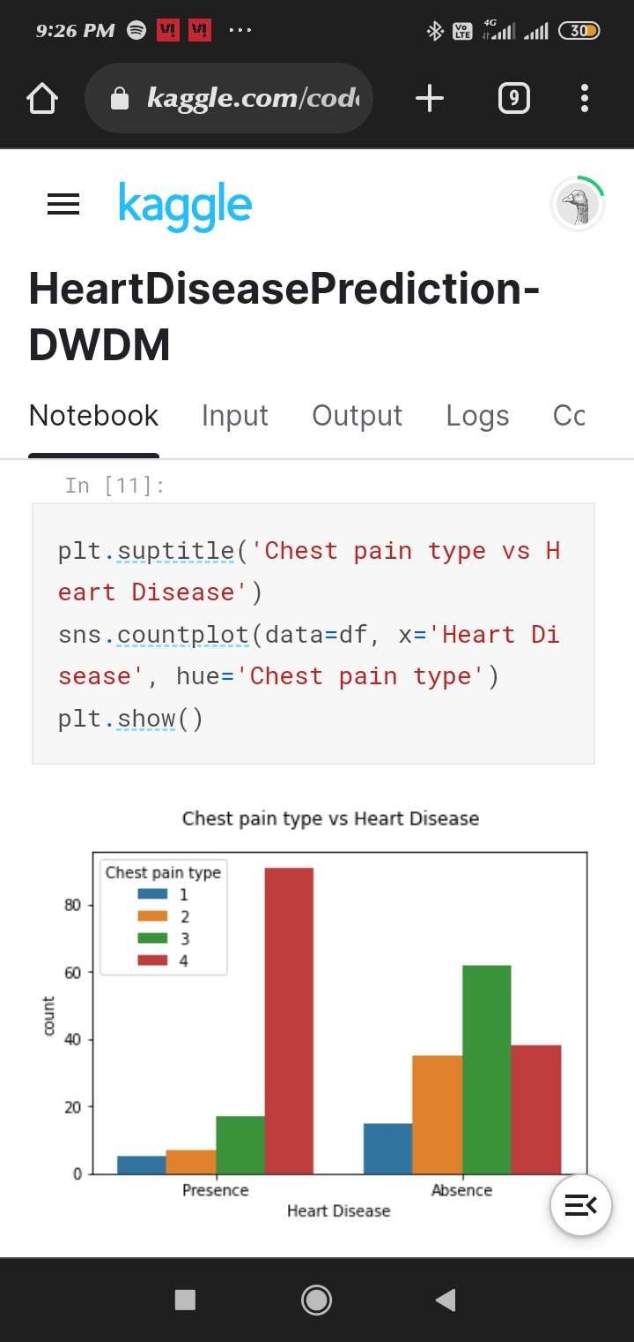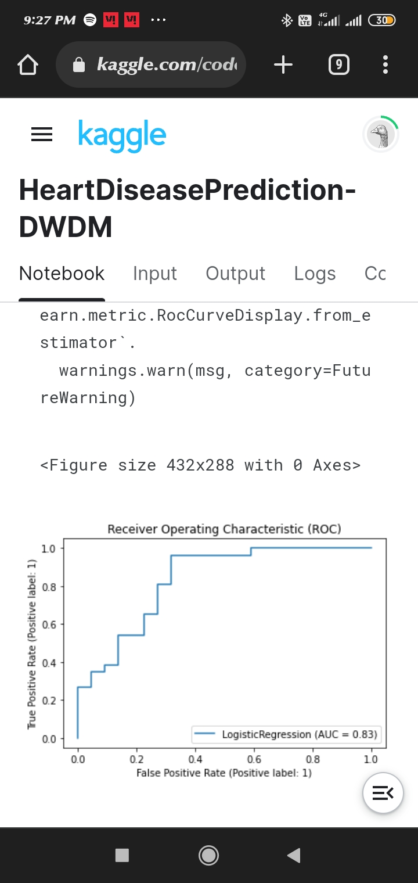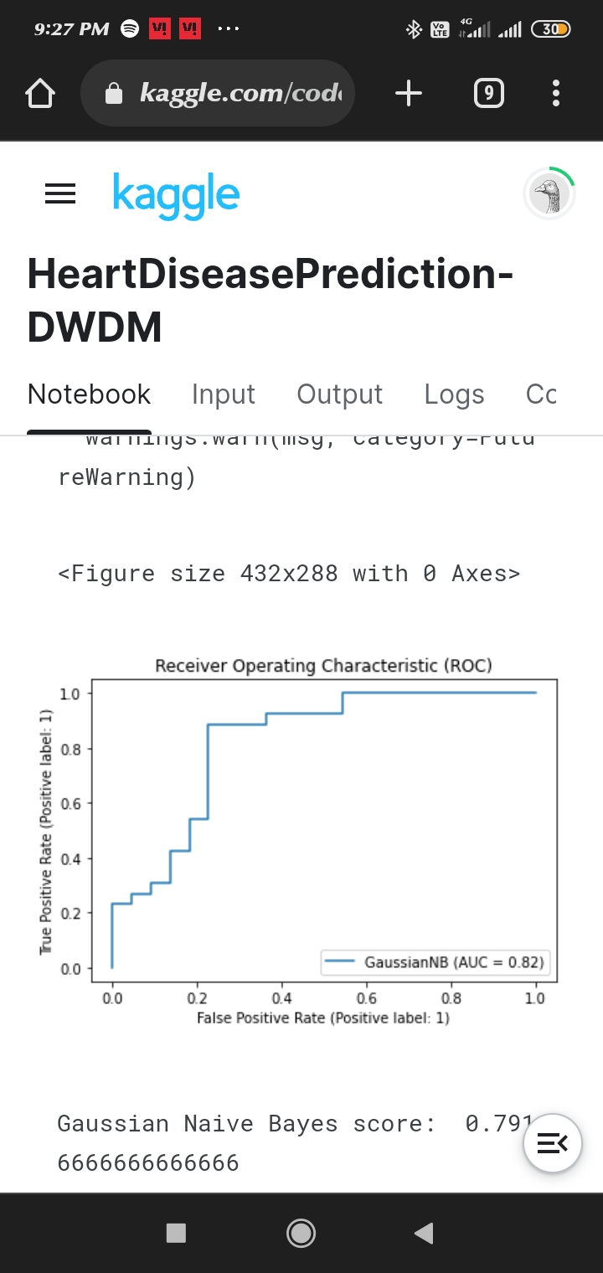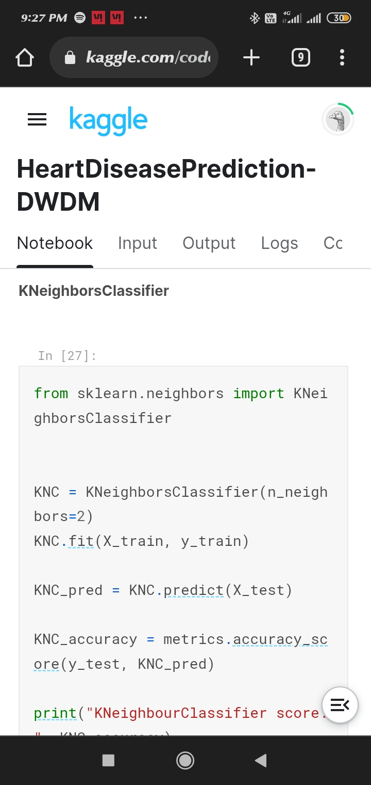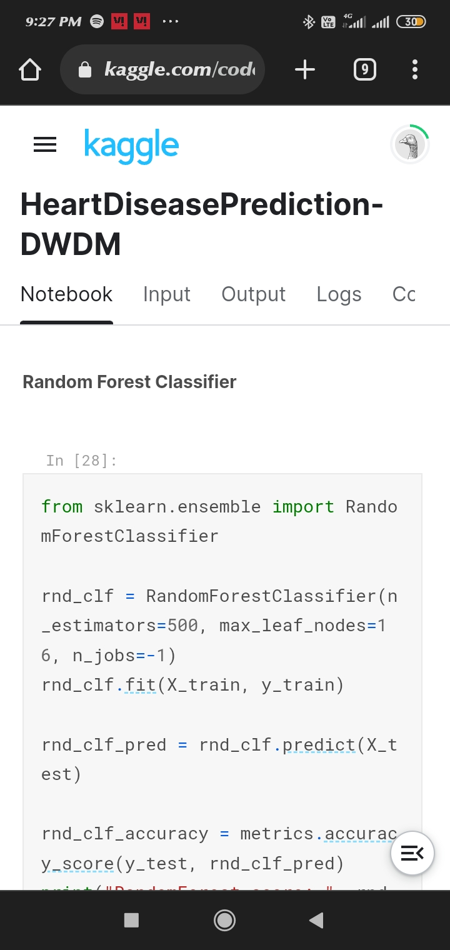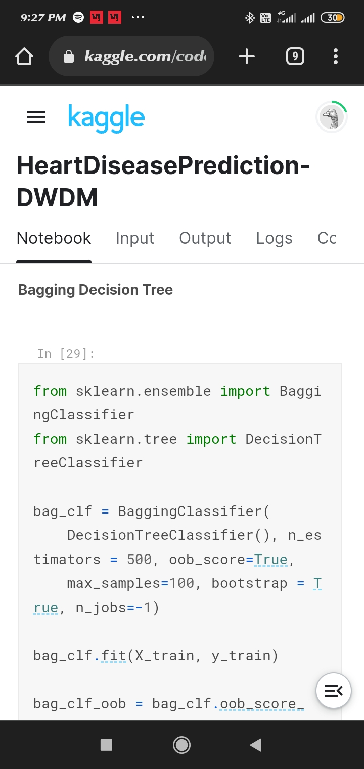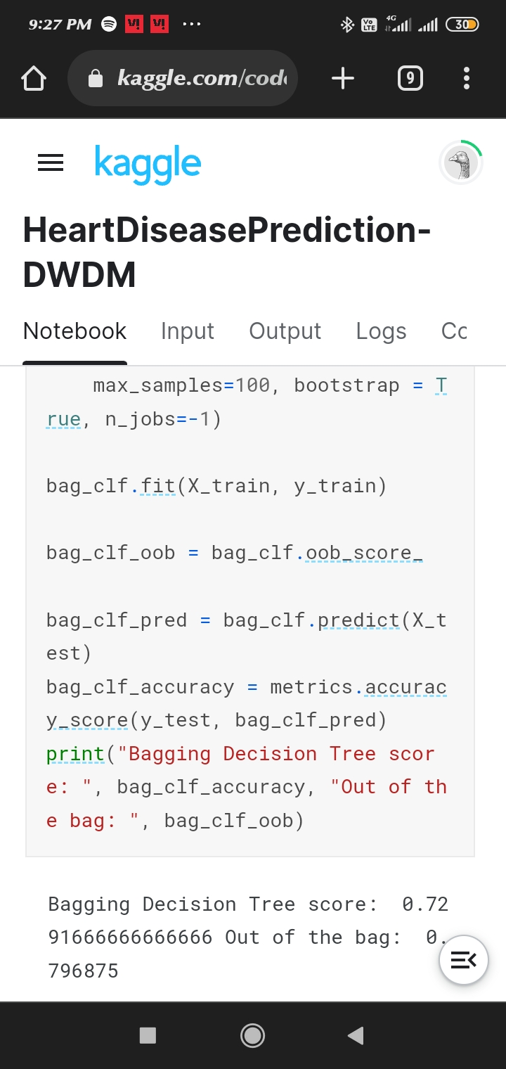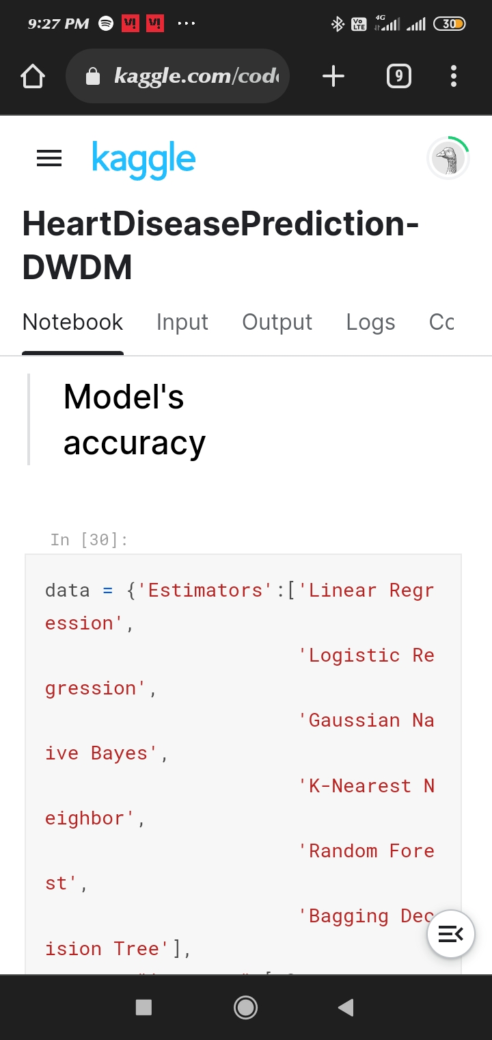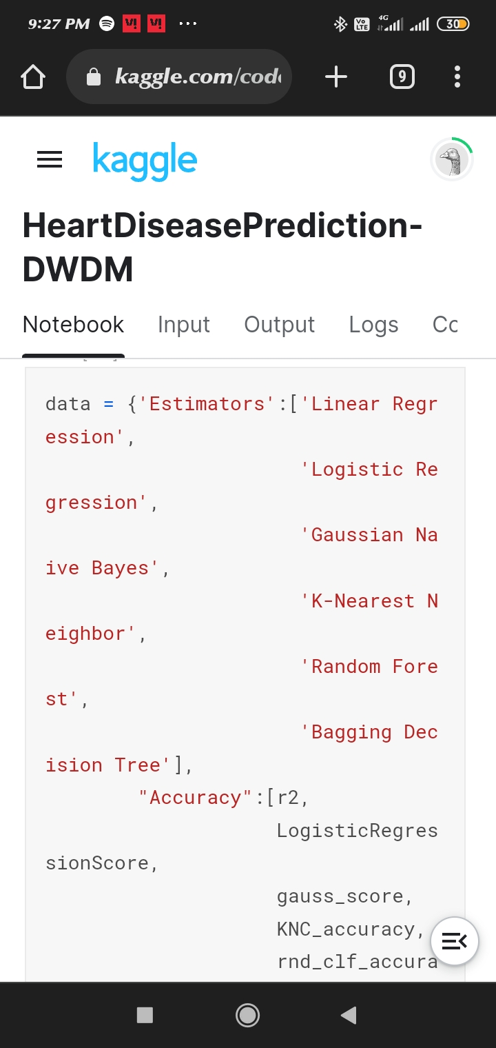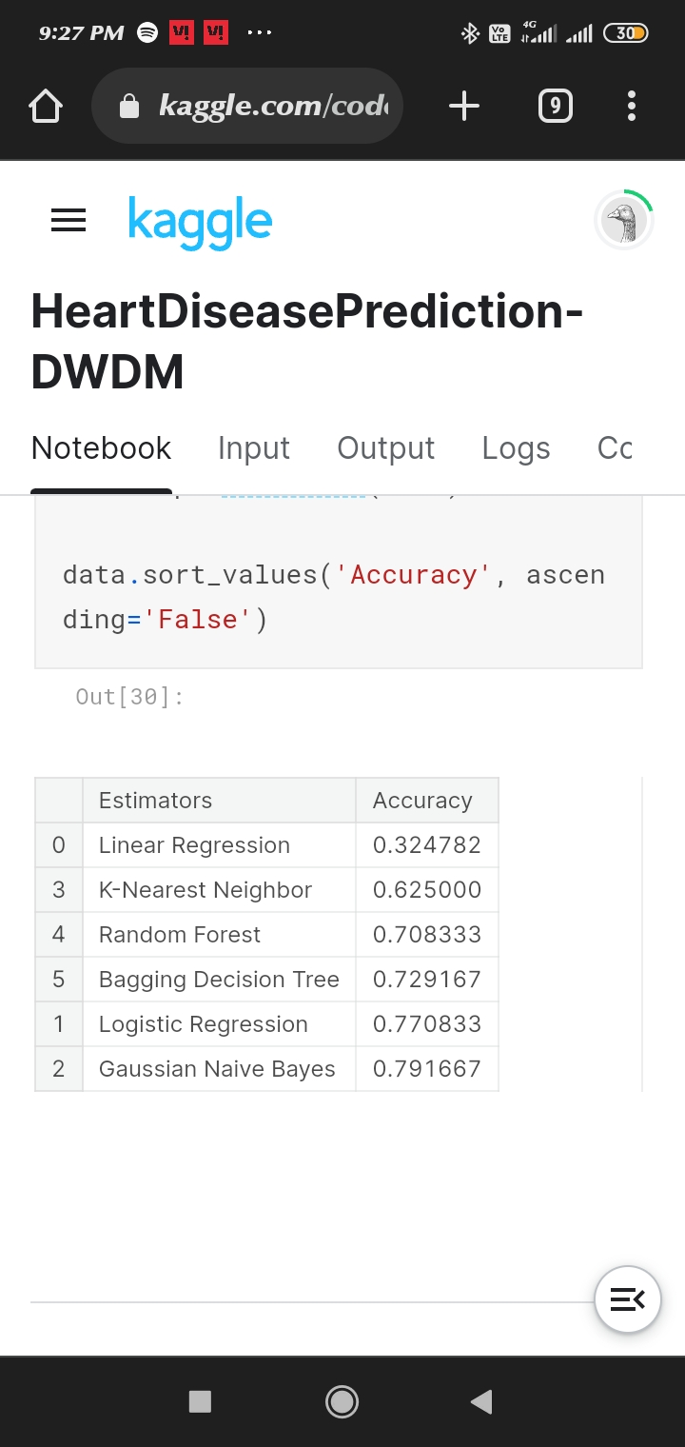

**SCREENSHOT:**

**HOME PAGE**

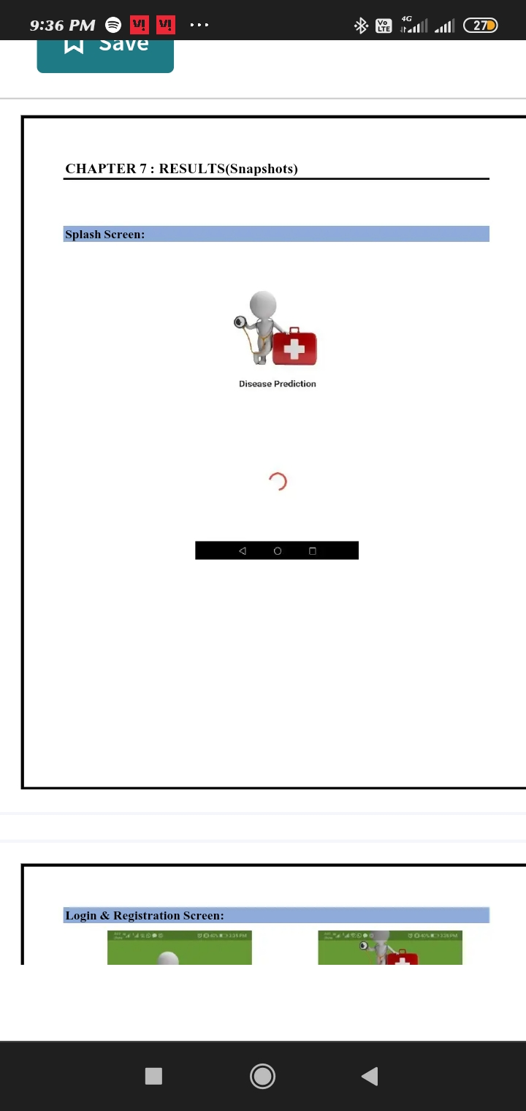

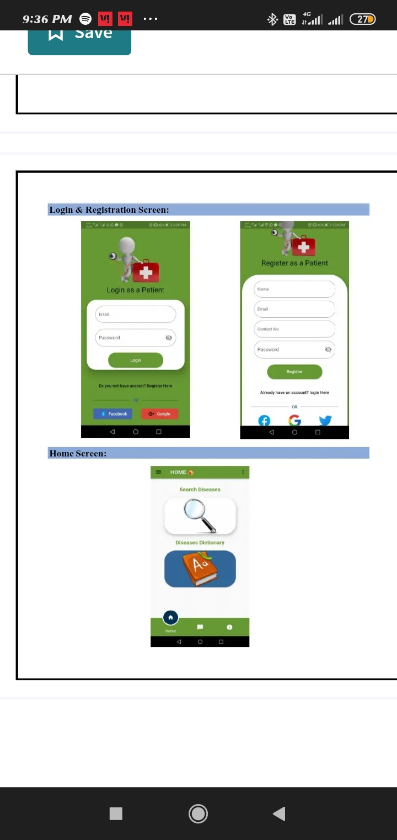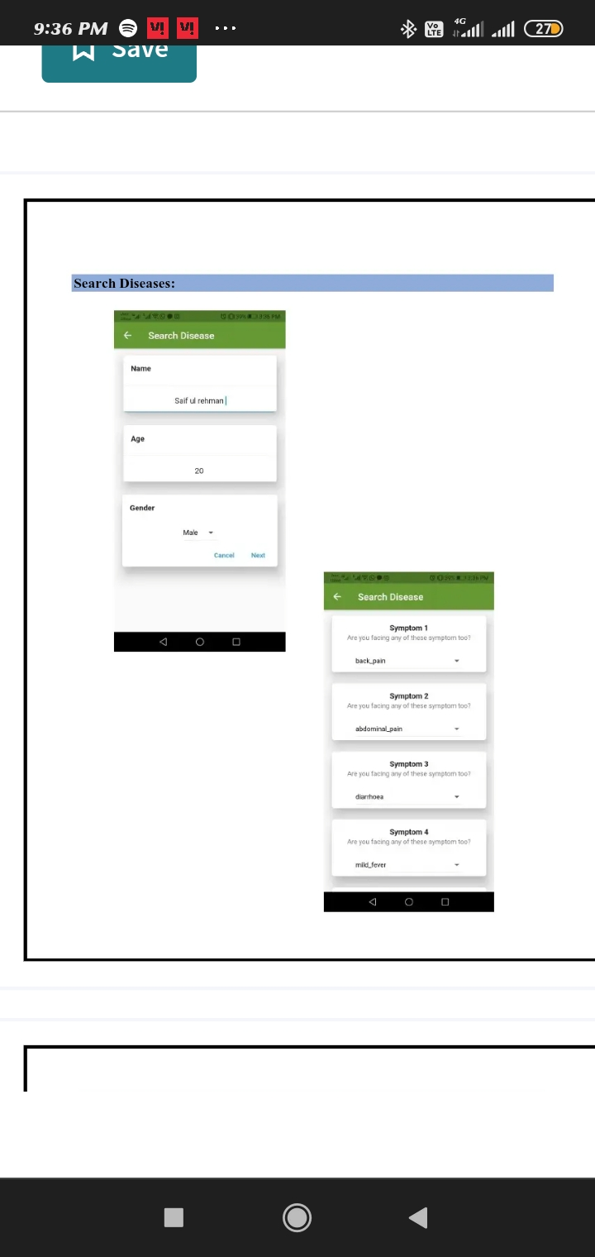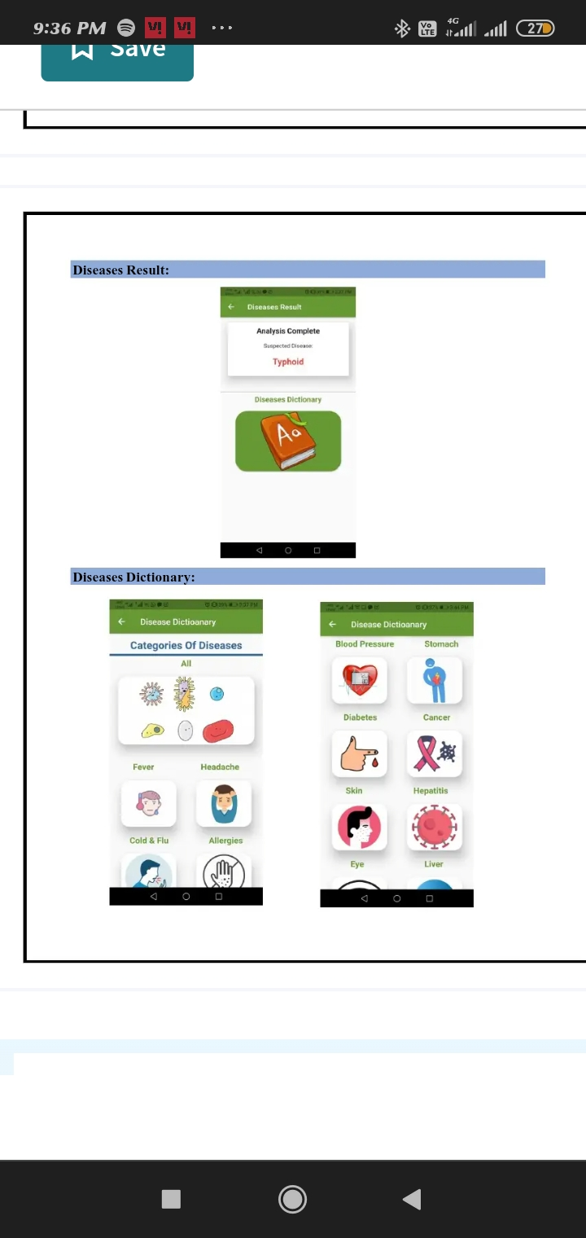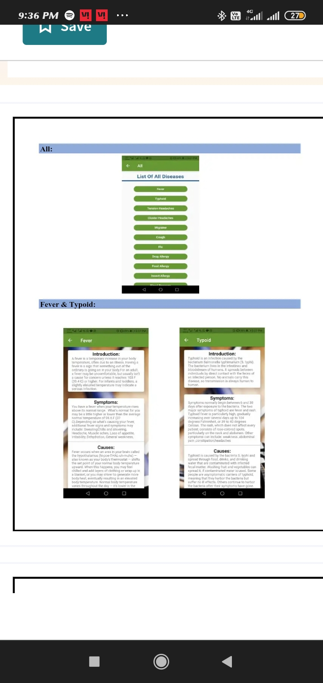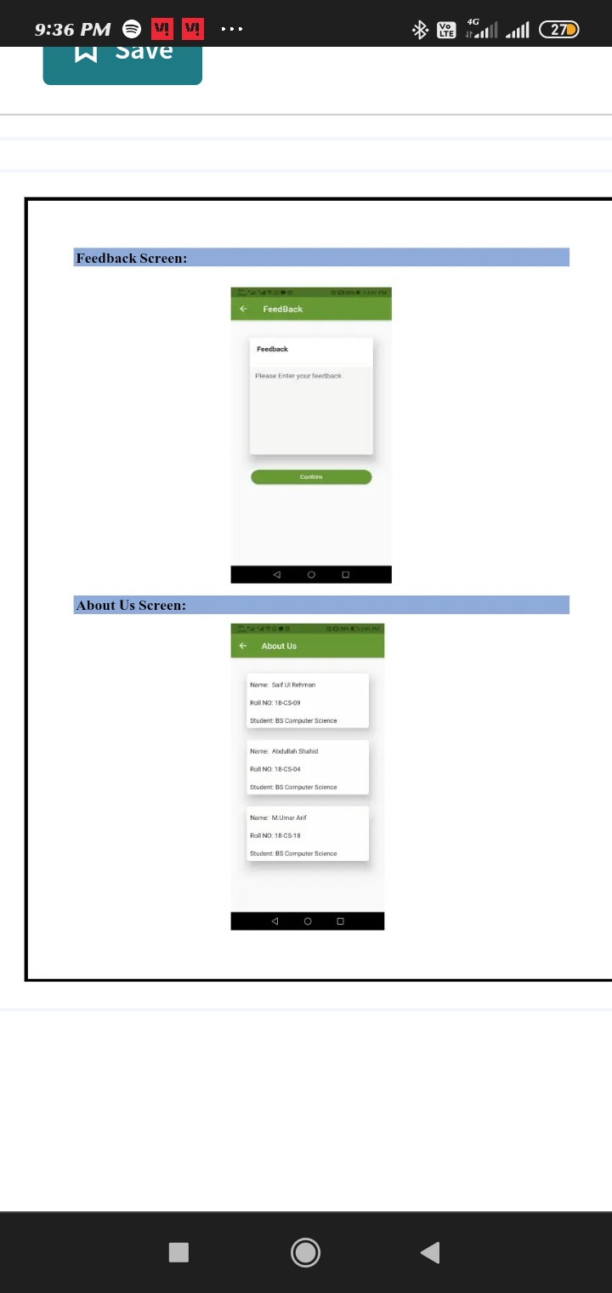

**Git Hub Link**

**https://github.com/Usha1979/Usha/blob/main/Heart_Disease_Prediction.csv**